**Assignment 1**

**Data Visualization of 2014 Election data**

rep_plot = data_units.groupby('STATE').mean().plot(kind='bar',figsize=(15,5))

rep_plot.set_xlabel("State")

rep_plot.set_ylabel("POLL PERCENTAGE")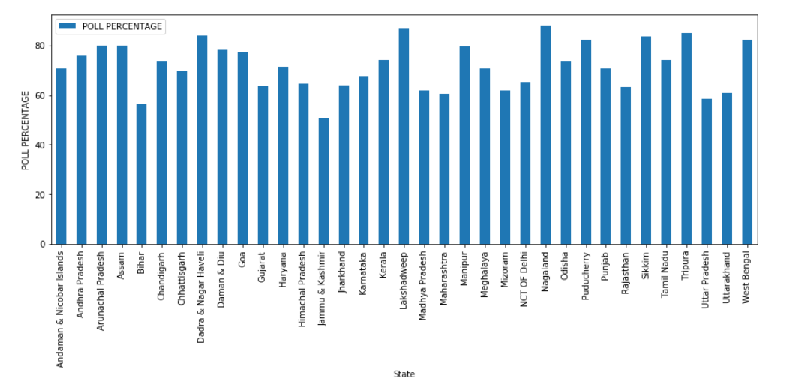

data_part = data[["STATE","Total voters"]]

rep_plot = data_part.groupby('STATE').sum().plot(kind='bar',figsize=(15,5))

rep_plot.set_xlabel("State")

rep_plot.set_ylabel("Total voters")

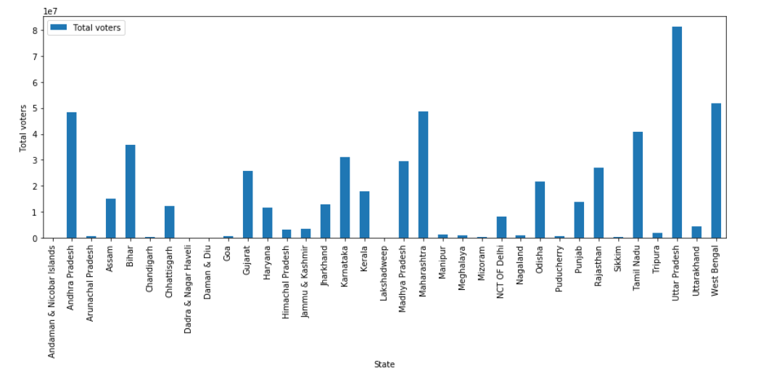

party=win.groupby('Party Abbreviation').size()

colors = ['red','purple','#7CFC00','orange','green','blue','yellow','pink']

party = party[party > 10]

party.plot(kind='pie',figsize=(15,5),colors=colors)

